**Prevalence of Responsible Selling Behaviors in An Online Firearms Marketplace**

In 2016, 37,353 persons died in the United States from firearm-related injuries; another 80,184 suffered non-fatal injuries (CDC WISQARS). Increased firearm deaths have been associated with lenient policies regulating gun sales and ownership (Webster et al. 2014 (PTP laws & MO death rates – sale related), Sumner et al. 2008 (death rates & background checks – sales related), Santaella-Tenorio et al. 2016 (laws & death rates - more ownership related, but includes sales pieces) **XX**). While dealers who have a federal firearms license (FFL) (e.g. brick-and-mortar retail outlets) must require gun buyers to pass a background check, private sellers are not under the same federal restrictions (webster 2009, miller et al. 2017).

Popular websites such as Armslist.com allow the sale of firearms by both private sellers and retail outlets. However, private sellers do not have to go through an FFL to make the sale (i.e. no background check is required) (NPR article). We assessed the number and proportion of private gun sales on Armslist.com that required a background check or other identification from the buyer before purchase (a practice we term “responsible selling”).

**Methods:** We ran a web-scraping algorithm May 4th, 2018 to June 29th, 2018 with the goal of extracting information about firearms for sale listed on Armslist.com. This algorithm is based on the Python package “Beautiful Soup”. Collected data included gun type, post title, date of post, and the post content. We removed irrelevant gun and advertising categories (e.g., “paintball” and “want to buy”, respectively) from the analysis. We defined a listing as displaying responsible selling if it contained at least one of the following terms or their corresponding acronyms full names/ acronyms of government issued document authorizing legal possession of firearms (e.g. Concealed carry license, CCL) or other key words such as “license” or “permit”.

**Results:** The web-scraping algorithm found 6.26 million posts on Armslist.com during data collection. After removing irrelevant gun and advertising categories, the remaining dataset contains 4.90 million posts listed between July 14, 2008 and June 25, 2018. Overall, 523,854 (10.68% [95% CI, 9.8%-11.56%]) indicated responsible selling (**Table**). The three most commonly observed gun categories observed were “handguns” (2,367,588; 47.92%), “rifles” (1,636,201; 33.13%), and “shotguns” (411,276; 8.32%). Among these categories, the proportion of posts displaying responsible selling behaviors were 48.28%, 33.37%, and 8.39%, respectively.

The percentage of advertisements displaying responsible gun-selling behavior increased from 2009 to 2018 (**Figure**). This increase was driven primarily by shotgun advertisements. From 2008-2012, X% of shotgun advertisements displayed responsible selling behavior, and this percentage increased/decreased from 2013-2018 to X%. There was no statistical in crease in responsible gun-selling behavior for rifles over this time period.

**Discussion**: Our findings indicate that, between 2008 and 2018, of the 4.90 million online advertisements on firearm for sale on Armslist.com, only a little over 10% contain responsible selling behaviors.

more than four million firearms, including automatic weapons, were available for purchase without a background check on Armslist throughout the United States over a ten-year period from 2008 to 2018. While responsible gun-selling behavior is increasing over time, over 85% of Armslist advertisements did not display responsible gun-selling behavior in the first half of 2018.

Policies requiring responsible selling behaviors have been associated with a reduction in firearm-related deaths (Webster et al. 2014, Sumner et al. 2008, Santaella-Tenorio et al. 2016). Although many online vendors require the transfer of ownership be made via an FFL (Gunbroker.com), Armlist.com does not have any such requirement. As a result, Armlist.com creates a large loophole in state and federal regulatory efforts to regulate firearm sales. Regulations will need to extend to the online market if they are to have their intended impact on firearm-related violence.

However, there are several limitations of this study. First, the number of posts do not necessarily equal to the number of firearms looking to be sold. Some posts include multiple pieces of firearms. Second, the rules about how online posts become deactivated is unknown. It is likely that some sellers remove their posts once the transactions have been completed. Our dataset only reflects the posts that were active during the data collection phase. It does not reflect the exhaustive list of posts that have historically existed. Thirdly, there are a wide range of government issued documents that authorize for legal firearm possession, varying state to state. We included all that we are aware of in the definition of responsible selling behavior. However, we acknowledge that there may be types of licenses and permits we have missed.

A limitation of our study is that we do not observe responsible gun-selling behavior at the point of sale, which is legally required (but it isn’t if it isn’t a federally licensed dealer is it?) and may not(?) occur. We also do not observe advertisements outside of Armlist.com.

Last paragraph suggestion:

A limitation of our study is that we do not observe responsible selling behavior at the point of sale (i.e. sellers may not explicitly ask for a background check, but conduct one prior to the transfer of ownership). While federal laws regulate sales among federally licensed dealers, regulations may also occur at the state- or local-level; however, our study did not consider these (Webster 2009). We also do not observe advertisements outside of Armlist.com.

In the last paragraph, I think we should suggest for at least three future directions that we will pursue. (1) identify better ways to identify responsible selling behaviors, currently we are only using keywords; (2) what is the spatial distribution of online gun selling posts? What is the spatial distribution of responsible gun selling posts? Does either of these of spatial clustering effects?; (3) does the spatial distribution of gun selling/ responsible selling behaviors correlate with the spatial distribution of injury? Mass shooting events? Other gun-related health end points? (Maria’s twitter article mentioned a bunch).

**Authors:**

Yang Liu, PhD1; Ashley Hernandez, MSPH2; Coleman Drake, PhD3; Adam Schwartz, PhD2; Maria Sundaram, MSPH, PhD4

**Affiliations:**

1London School of Hygiene and Tropical Medicine

2 University of Minnesota School of Public Health

3 University of Pittsburgh Graduate School of Public Health

4 Emory University Rollins School of Public Health

**References**

**Table**. Number and Percentage of Advertisements Displaying Responsible Gun-Selling Behavior by Gun Typea

|  |  |  |
| --- | --- | --- |
| Gun type | Number of advertisements selling this gun type | Percentage of posts displaying responsible selling (%) |
| Handguns | 2,367,588 | 14.32 |
| Rifles | 1,636,201 | 8.80 |
| Shotguns | 411,276 | 6.95 |
| Gun | 261,189 | 2.17 |
| Tactical | 79,469 | 0.82 |
| Antique | 52,493 | 6.82 |
| Reloading | 47,624 | 0.31 |
| Muzzle | 33,057 | 2.90 |
| NFA | 8,588 | 11.35 |
| Firearms | 5,827 | 5.05 |
| Other | 347 | 2.02 |
| All | 111 | 12.61 |
| Total | 4,903,805 | 10.68 |

a Data are from a web scrape of Armslist.com from **DATE TO DATE**

b Responsible gun-selling behavior is defined as displaying at least one of the following terms or their corresponding acronyms: Concealed carry weapon (CCW); concealed carry license (CCL); federal firearm license (FFL); permit to purchase (P2P); background check; license; permit; or required.

**Figure.** Percentage of Gun Advertisements Not Displaying Responsible Gun-Selling Behavior over Timea

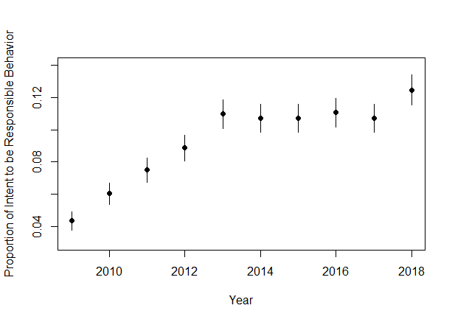

a Data are from a web scrape of Armslist.com from **DATE TO DATE**